W and Z boson candidates

Z decay to muon and anti-muon:
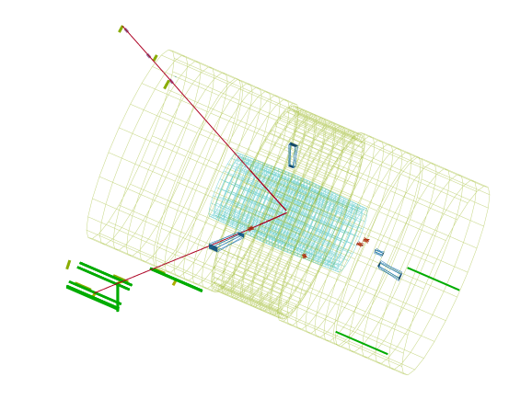

Z decay to electron and positron:
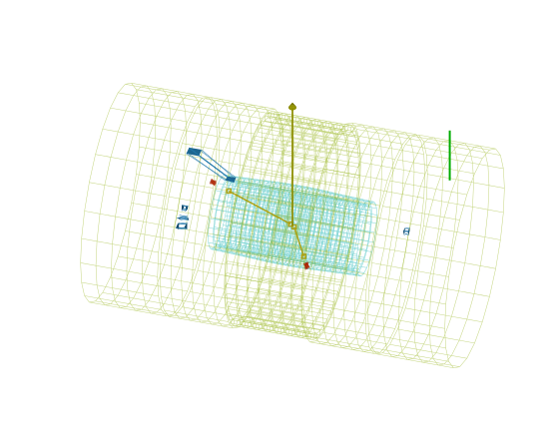
W decay to electron and neutrino:
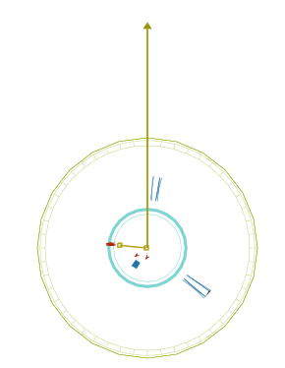

W decay to muon and neutrino:
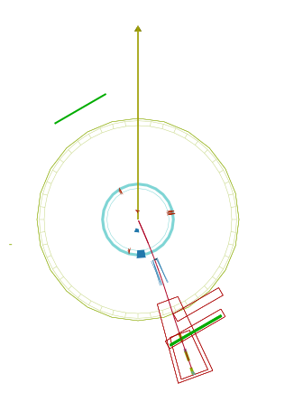
Notes on decays:
- W decays have missing E_{t} (usually>20 GeV) and one visible lepton track.
- Z decays can show some missing E_{t} (usually<20GeV) or none and have 2 visible lepton tracks.
- Both W and Z decays can have “extra” tracks which confound quick analysis – but a “good guess” can sometimes be made.

Useful background on W/Z Masterclass events

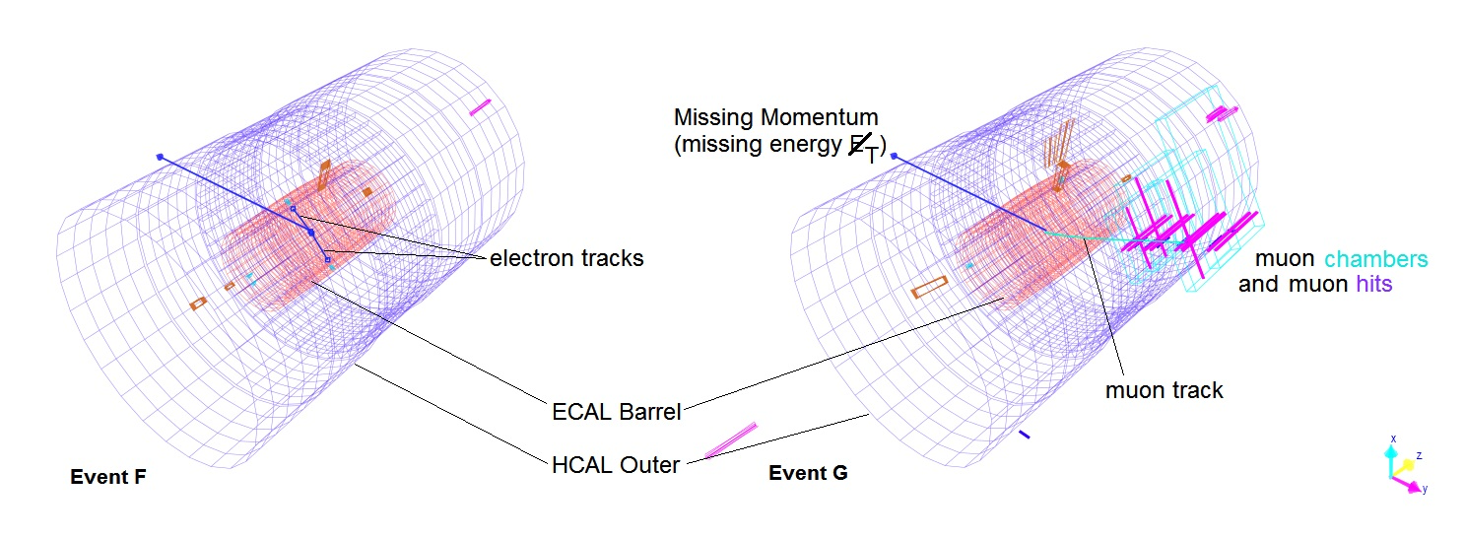

Elements of W/Z events from iSpy-online

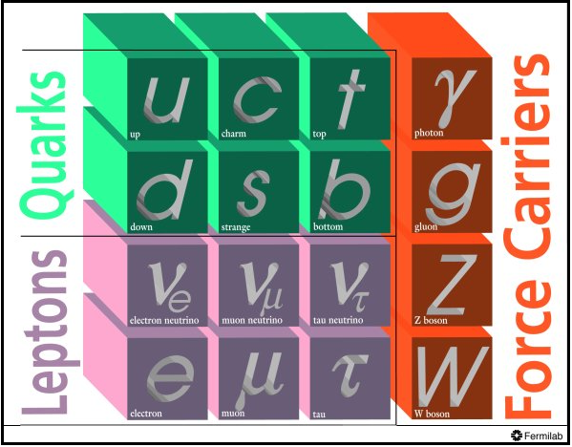
Particles in the standard model

